SSMS Summer Reading List

Incoming Grades 6, 7 & 8

“I read for pleasure and that is the moment I learn the most.”

-- Margaret Atwood

“If you don’t like to read, you haven’t found the right book.”

--J.K. Rowling

***Requirements:***

1) **Choose one book from your grade level list.** Of course, more is always desirable! Find them at the Rockville Centre Public Library, bookstores, and on audiobook or eReader (Nook, Kindle, iPad, etc.)

2) **Reading response worksheets are required of all students**. Worksheets are located after each grade level list. Complete the tasks, and have your notes available for your Language Arts class in September. Your Language Arts teacher will provide an actual due date following the third week of school. This reading response work will count toward your independent reading grade in some way, and your teacher *may* ask you to extend your notes into compositional writing.

*Avid readers . . .*

⇒ *Build background knowledge*

⇒ *Gain empathy*

⇒ *Increase sensitivity to the power of language*

⇒ *Stimulate vocabulary acquisition, retention and articulation*

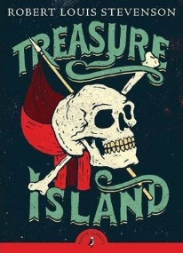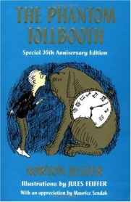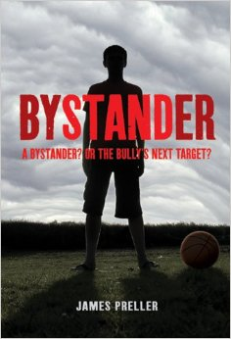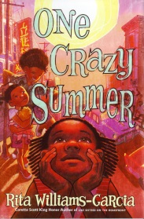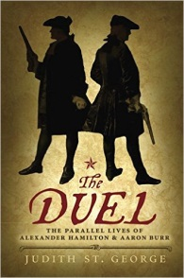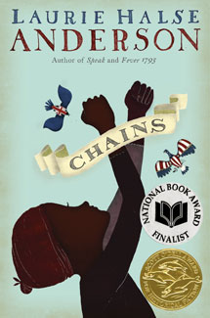

Incoming Grade 6

**Treasure Island** - Robert Louis Stevenson

With map in hand, Jim Hawkins sets sail to find Treasure Island, where a fortune is hidden. But evil buccaneer Long John Silver will stop at nothing to get that gold first *(Classic/Adventure)*

**Little Women** - Louisa May Alcott

Laugh and cry with the four March sisters as they argue, fall in love, and have their hearts broken during and after the Civil War. *(Classics)*

**The Phantom Tollbooth** - Norton Juster

Imagine if on the most boring day of your life, a magic tollbooth appears. You drive your toy car through to find adventure. *(Classics/Fantasy)*

**Bystander** - James Preller

Bullies…If you’re not part of the solution, you’re part of the problem. Will you just stand there and watch, or will you do something? *(Anti-Bullying/Tolerance)*

**Amelia Lost: The Life and Disappearance of Amelia Earhart** - Candace Fleming

In 1937, Amelia attempts to do the impossible, circumnavigate the globe,

but she vanishes without a trace. *(Biography)*

**One Crazy Summer** - Rita Williams Garcia

Delphine and her little sisters are sent from Brooklyn to California to spend the summer with a mom they barely know. The sisters’ story continues in **P.S. Be Eleven** and **Gone Crazy in Alabama.** *(Historical Fiction)*

Grade 6: Page 1 of 4

**Chains** - Laurie Halse Anderson

Isabel, a slave sold to a cruel Loyalist couple in Manhattan (yes, even New York had slaves), puts her life on the line for freedom by spying for the Patriots. Book 2: **Forge** and Book 3: **Ashes**. *(Historical Fiction)*

**The Duel: The Parallel Lives of Alexander Hamilton & Aaron Burr** - Judith St. George

Hamilton and Burr were both orphaned at an early age. Both were brilliant students who studied law. Both were war heroes. And each served in the newly formed government of the fledgling nation. So why did they face each other in a duel that ended with death and infamy?

*(Biography)*

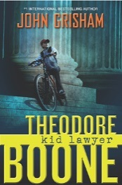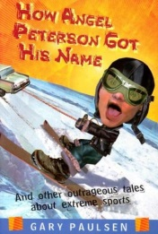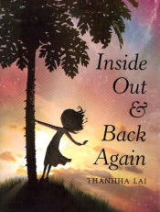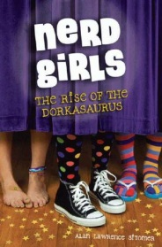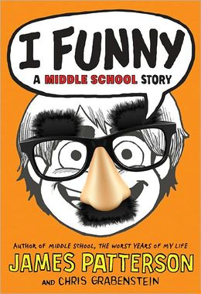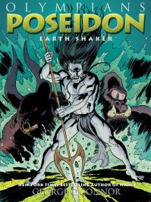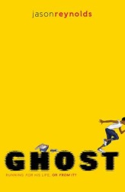

Incoming Grade 6 - continued

Grade 6: Page 2 of 4

**The Story of Apple** - Sara Gilbert

Have an iPhone, an iPad? It’s time to learn more about this amazing company and how it changed our lives. *(Science/Technology)*

**Ghost** - Jason Reynolds

Ghost wants to be the fastest sprinter on his elite middle school track team, but his past is slowing him down. *(Sports)*

**Theodore Boone: Kid Lawyer** - John Grisham

This lawyer finds himself knee-deep in a huge murder trial, and he is only 13!

Book one of a series. *(Adventure)*

**How Angel Peterson Got His Name: And Other Outrageous Tales about Extreme Sports** - Gary Paulsen

Before helmets, fun could be dangerous. Find out how, laugh out loud, but don’t try it at home! *(Comedy/Biography)*

**Inside Out and Back Again** - Thanhha Lai

New country, new school, new language. Talk about a triple challenge! *(Multi-cultural)*

**Nerd Girls: The Rise of the Dorkasaurus** - Alan Lawrence Sitomer

Will the 3 Ps (pretty, popular and perfect) and winners of every talent show be taken down? Nerd girls unite! Book 2: **The Catastrophe of Nerdish Proportions.** *(Realistic Fiction)*

**I Funny** - James Patterson and Chris Grabenstein

Jamie Grimm has decided to become the world’s greatest stand-up comedian even though he’s still in middle school. For more laughs read **I Even Funnier** and **I Totally Funnier**. *(Comedy)*

**The Olympians** - George O’Connor

The Greek gods get the superhero treatment in this series featuring Zeus, Athena, Hera, Hades, Poseidon, Aphrodite, Ares, Apollo and Artemis. *(Graphic Novel)*

**The Maze Runner** - James Dashner

You wake up with no memory of who you are, where you are or how you got there. You need to escape, but how? The trilogy continues with **The Scorch Trials** and **The Death Cure** and a prequel, **The Kill Order**. *(Sci-Fi)*

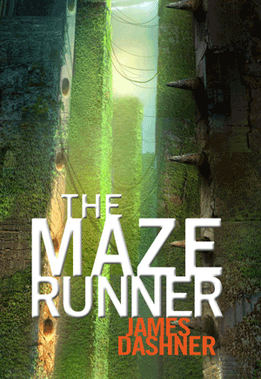

**Sixth Grade Summer Reading Worksheet**

Student:__________________________________ School Year: _____________

Title: ________________________________________

Author: _____________________________

Genre: _____________________

Why did you choose this book? ____________________________________________________________

_____________________________________________________________________________________

_____________________________________________________________________________________

**Basic Story Elements Overview**

1. Setting (where & when):

2. Conflict (the main problem or struggle the characters face):

3. Resolution (How was the conflict resolved?):

4. Theme: (What life lesson did the author intend for the readers to learn? What events support this?)

5. In the end, did the book live up to your expectations? Explain why or why not.

Grade 6: Page 3 of 4

**6**. **Character and Characterization:** In preparation for your Summer Reading Assignment, fill out the chart below.

**Directions:** A character trait is a word that is used to describe how a character typically behaves. Choose one character with **positive** character traits from your novel and fill out the chart below. The character traits should be higher level. Try to avoid words like *kind, caring,* and *nice*. Using a thesaurus will be helpful when you are looking for higher level words. **Be careful not to use emotions, as they are not character traits.**

**Character Name**: _______________________________

|  |  |  |
| --- | --- | --- |
| **Positive**  **Character Trait:** | **Reason why you think this:** | **LEAVE THIS COLUMN BLANK FOR NOW** |
| **Example**: generous | **Example**: Bobby collected spare change for three months. He cashed it in and decided to donate the money to a local animal shelter. |  |
|  |  |  |
|  |  |  |
|  |  |  |

Grade 6: Page 4 of 4

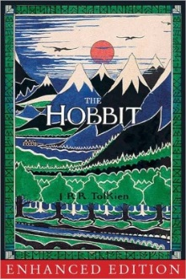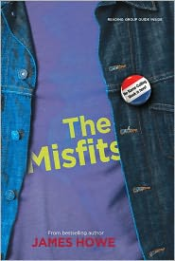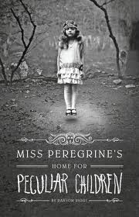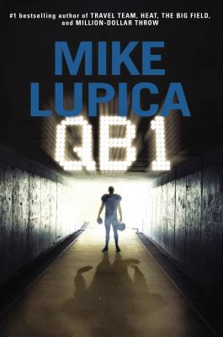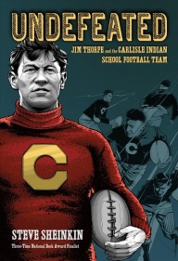

Incoming Grade 7

**The Hobbit, or, There and Back Again** - J. R. R. Tolkien

The saga of the ring starts here when Bilbo Baggins is dragged from his cozy hobbit hole into adventure. Prequel to The Lord of the Rings trilogy. *(Core Curriculum)*

**Miss Peregrine’s Home for Peculiar Children -** Ransom Riggs A mysterious island. An abandoned orphanage. A strange collection of very curious photographs. Story continues in **Hollow City** and **Library of Souls**. *(Magical Realism)*

**The Lion, the Witch and the Wardrobe** - C. S. Lewis

The White Witch and Aslan the lion await you. Open the wardrobe and enter the magical world of Narnia. Enjoy all the books in the Chronicles of Narnia series. *(Classics)*

**The Misfits** - James Howe

Tired of being bullied, four friends try to end name-calling by forming a new student council political party, “The No-Name” party. Read the companion books **Totally Joe** and **Also Known as Elvis**. *(Anti-Bullying/Tolerance)*

**Flygirl** - Sherri L. Smith

Before World War II, women only dreamed of being pilots. But Ida breaks color and gender barriers by flying to help the war effort. *(Historical Fiction)*

**Undefeated: Jim Thorpe and the Carlisle Indian School Football Team** - Steve Sheinkin

When superstar athlete Jim Thorpe and football legend Pop Warner met in 1904 at the Carlisle Indian Industrial School, they forged one of the winningest teams in American football history. They were so good they were called "the team that invented football." *(Biography/Sports)*

Grade 7: Page 1 of 6

**QB 1** - Mike Lupica

Jake Cullen, fourteen, lives in the shadows of his father and older brother until he becomes the starting quarterback for the high school football team. Inspired by the Manning family.  *(Sports)*

**A Long Walk to Water** - Linda Sue Park

Two journeys converge in the Sudan: in 1985 during the civil war, Salva is separated from his family and must walk through three countries in search of safe haven. While in 2008, Nya walks eight hours a day in search of water for her family. *(Multi-cultural)*

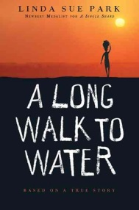

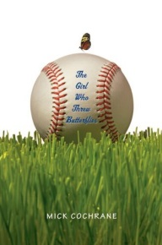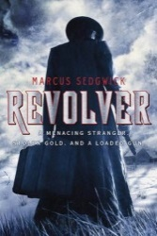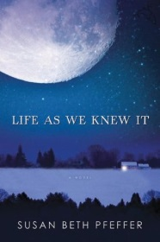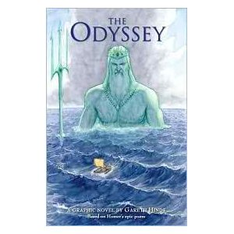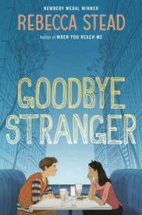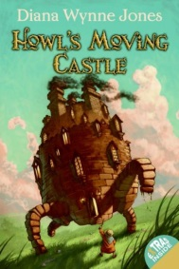

**The Girl Who Threw Butterflies** - Mick Cochrane

The pitcher on the boy’s baseball team throws a great knuckleball . . . but the pitcher is a girl. *(Sports)*

**Revolver** - Marcus Sedgwick

A teen returns to his isolated cabin to find his father frozen to death and a gun-toting stranger demanding his stolen gold in this chilling Arctic mystery. *(Adventure/Mystery)*

**Life as We Knew It** - Susan Beth Pfeffer

A meteor hits the moon and in one moment the whole world changes. Food and heat are almost nonexistent. One girl journals her family’s desperate struggle for survival. If you like this one, there are three more companion/sequel books. *(Sci-fi/Survival)*

**Flipped** - Wendelin Van Draanen

There are three sides to every story, his side, her side and the truth. An eighth grade boy and girl tell their sides. *(Comedy/Realistic Fiction)*

**Goodbye Stranger** - Rebecca Stead

As Bridge makes her way through seventh grade on Manhattan's Upper West Side with her best friends, she finds the answer she has been seeking since she barely survived an accident at age eight: "What is my purpose?" *(Growing Up/Realistic Fiction)*

**The Odyssey: The Graphic Novel** - Gareth Hinds

Like Percy Jackson? Try this retelling of Greek hero Odysseus’ battles with gods, witches and creatures of all kinds as he returns home from the Trojan War. *(Graphic Novel)*

**Howl’s Moving Castle** - Dianne Wynn Jones

In a word, delightful! This is a must-read for any fantasy fans. Sophie has the great misfortune of being the eldest of three daughters, destined to fail miserably. She finds herself under a spell that transforms her into an old lady, and her only hope is the heartless wizard Howl and his fire demon, Calcifer. *(Fantasy)*

Incoming Grade 7 - continued

**Nelson Mandela: South African Revolutionary** - Beatrice Gormley

Discover the man behind the smile and how Mandela went from peaceful protester against apartheid, to political prisoner, to president and Nobel Peace Prize laureate. *(Biography)*

Grade 7: Page 2 of 6

Seventh Grade SSMS Summer Reading Response Worksheet

Name: ______________________________________________ 7th Grade (2019-2020)

**Directions:** Please be sure to READ over this entire handout before reading the summer reading of your choice. Note your purpose for reading the text. Use the worksheet while you read the text. **Be an active reader!** You may type your responses or use extra paper if needed.

Title (capital letters/ underline):

_____________________________________________________________________________

Author (first and last name):

_____________________________________________________________________________

Genre (science fiction, fantasy, historical fiction, realistic fiction, etc…):

_________________________________________________________________________

1. Setting (where & when/time period):

__________________________________________________________________________________________________________________________________________________________

2. Characters and Characterization

a) Characterization of Protagonist

• Identify who the protagonist (main character.) of the text is. If the text selected has multiple protagonists, choose ONE.

• Characterize using text details/citations (physical and personal attributes)

_____________________________________________________________________________

______________________________________________________________________________

______________________________________________________________________________

_____________________________________________________________________________

_____________________________________________________________________________

Grade 7: Page 3 of 6

Grade 7: Page 3 of 4

1. **Characterization of Antagonist**

* Identify the antagonist (opposing character, group, or force of the text is.
* Characterize using text details/citations (physical and personal attributes)

**________________________________________________________________________________________________________________________________________________________________________________________________________________________________________________________________________________________________________________________________________________________________________________________________**

**3.** **Conflict** (problems or struggles the characters face)

1. **Internal conflict(s)** faced by the protagonist (doubts, fears, decisions etc)

**________________________________________________________________________________________________________________________________________________________________________________________________________________________________________________________________________________________________________________________**

_____________________________________________________________________________

1. **External conflict(s)** faced by the protagonist (due to outside challenges/conditions)

**_________________________________________________________________________________________________________________________________________________________________________________________________________________________________________________________________________________________________________________________________________**

__________________________________________________________________

Grade 7: Page 4 of 6

1. **Resolution** (Was the conflict resolved? If so, how? If not, why?):

**_______________________________________________________________________________________________________________________________________________________________________________________________________________________________________________________________________________________________________________________**

1. **Theme** (What lesson did the author intend for readers to learn? What events support this?):

**_________________________________________________________________________________________________________________________________________________________________________________________________________________________________________________________________________________________________________________________________________________________________________________________________**

1. **Evidence of Dynamic Characterization: Determine how the protagonist changed from the beginning of the book to the end of the book. The adjectives used as traits should most likely be ANTONYMS!**

**Example:** A protagonist could behave cowardly at the beginning of a book but become brave over time. A protagonist could have been immature at the beginning of a book and becomes mature.

**Character trait at the beginning of the book: ________________________________**

**Give Text citations to support the character trait (Put citations in quotes and include the page number): ___________________________________________________________________________________________________________________________________________________________________________________________________________________________________________________________________________________________________________________________________________________________________________________________________**

**What motivates the character to change? Explain what leads to the character’s transformation.**

**_________________________________________________________________________________________________________________________________________________________________________________________________________________________________________________________________________________________________________________________________________________________________________________________________**

**Character trait at the end of the book. This trait should be the opposite of the trait at the beginning of the book:_________________________________________**

**Text citation to support character trait Put citations in quotes and include the page number): ________________________________________________________________________________________________________________________________________________________________________________________________________________________________________________________________________________________________________________________**

Grade 7: Page 6 of 6

**We Were Liars** - E. Lockhart

Each summer the wealthy, seemingly perfect Sinclair family gathers on their private island, but there is one summer Cadence Sinclair cannot remember. *(Realistic)*

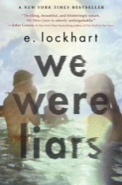

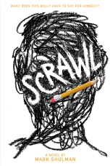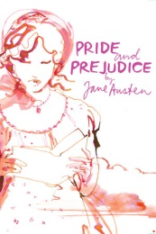

**Pride and Prejudice** - Jane Austen

Every rom-com movie is based on this story. He’s proud, she’s judgmental. Will they ever get together? *(Classics)*

Incoming Grade 8

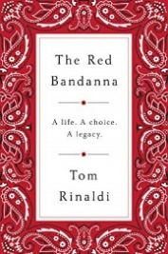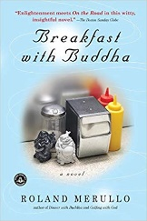

**Monster** - Walter Dean Myers

Told from the point of view of Steve, on trial for murder: “Sometimes I feel like I have walked into the middle of a movie. Maybe I can make my own movie . . . I'll call it what the lady prosecutor called me . . . Monster.” *(Common Core)*

**The Red Bandana** – Tom Rinaldi

What would you do in the last hour of your life? Welles Crowther’s actions on 9/11

offer a lasting lesson on character, calling, and courage.

**Scrawl** - Mark Shulman

Enter the mind of a bully by reading his journal. *(Anti-Bullying/Tolerance)*

**American Born Chinese** - Gene Luen Yang

Three characters, trying to fit in. Jin Wang is at a new school where he's the only Chinese-American student; Danny is an all-American boy, but his obnoxious Chinese cousin Chin-Kee's visit ruins his reputation; The Monkey King decides he want to be a god. *(Graphic Novel)*



**Breakfast with Buddha -** Roland Merullo

When his sister tricks him into taking her guru on a trip to their childhood home,

Otto Ringling is not amused. On the road with an enigmatic holy man isn’t at all what

he'd planned! To amuse himself, he shows the monk some "American fun."

Grade 8: Page 1 of 5

**Mexican Whiteboy** - Matt de la Peña

Danny’s brown. Half-Mexican brown. And that means everyone else knows exactly who he is before he even opens his mouth. Before they find out he can’t speak Spanish, and before they realize his mom has blond hair and blue eyes, they’ve got him pegged. *(Multi-cultural)*

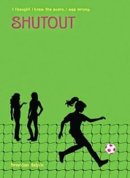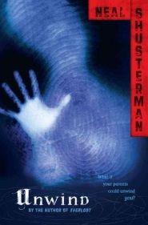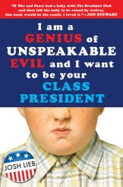

Incoming Grade 8 - continued

**Endangered** - Eliot Schrefer

Caught in the crosshairs of a lethal revolution in the Congo, Sophie and a baby bonobo struggle to survive in the jungle. *(Multi-cultural/Adventure)*



**Shutout** - Brendan Halpin

Freshman year gets more complicated for two best friends when only one is picked for varsity soccer. *(Sports)*

**Take Me to the River** - Will Hobbs

A canoe trip down the Rio Grande turns into a treacherous struggle for survival in the wake of deadly hurricane. *(Adventure/Survival)*

**Unwind** - Neal Shusterman

In the future, after the Second Civil War, parents of problem children can have them “unwound” and their body parts donated. Three teens run away to try to escape this terrible fate. Continue the trilogy with **UnWholly** and **UnSouled.** *(Adventure/Survival)*

**The Adoration of Jenna Fox** - Mary E. Pearson

If you are more fake parts than original, are you still you? How far would your parents go to save your life? Continue the trilogy with **The Fox Inheritance** and **Fox Forever.** *(Sci-fi)*

**I Am a Genius of Unspeakable Evil and I Want to be Your Class President** - Josh Lieb

A mad evil genius who wants to dominate the world settles for the middle school class elections instead. *(Comedy)*

**The Curious Incident of the Dog in the Night-time** - Mark Haddon

A math genius who is afraid of people pretends to be Sherlock Holmes and investigates the murder of a neighbor’s dog. He uncovers more mysteries than he expected. *(Mystery)*

**Speak** - Laurie Halse Anderson

Melinda Sordino finds herself an outcast at her high school for calling the cops on an end of summer party, and, although she finds comfort in her art class, she still holds a terrible secret. *(Trauma)*

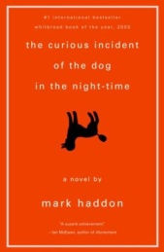

Grade 8: Page 2 of 5

**Eighth Grade Summer Reading Worksheet**

Name: ___________________________________________________________________________

Fircz / Giacone / Wasserman Period: _____

**TAG**

**T**itle of book: ______________________________________________________________________

**A**uthor: ___________________________________________________________________________

**G**enre: ____________________________________________________________________________

**THEME**

What lesson could be learned through the reading of this book? What might the author have wanted his/her readers to better understand about life?

____________________________________________________________________________________

____________________________________________________________________________________

____________________________________________________________________________________

**STORY ELEMENTS**

**Setting**:

*Where*: Broadly speaking, where is your character from?

___________________________________________________________________________________

*Where*: Describe the environment where the most important events take place:

____________________________________________________________________________________

*When*: Broadly speaking, during what time period / era does this story place?

_____________________________________________________________________________________

*When*: During what stage or point in your character’s life does this story take place?

Grade 8: Page 3 of 5

**Characters & Characterization:**

Protagonist: Describe the main character (who is central, dynamic) who learns a lesson, whose identity is challenged, or who experiences significant change:

____________________________________________________________________________________

Characterization of Protagonist (Personality traits, etc.):

____________________________________________________________________________________

Antagonist: Describe the opposing character, group, or force:

_____________________________________________________________________________________

Characterization of Antagonist (Personality traits, etc.):

____________________________________________________________________________________

**Conflict:**

Internal conflict(s) faced by the Protagonist: (i.e. doubts, fears, etc.):

_____________________________________________________________________________________

_____________________________________________________________________________________

External conflict(s) faced by the Protagonist (due to outside challenges / conditions):

_____________________________________________________________________________________

_____________________________________________________________________________________

Central challenge / conflict causing change for the Protagonist:

_____________________________________________________________________________________

_____________________________________________________________________________________

**Turning Point:**

At what point did your main character experience the greatest challenge / moment of decision? Describe this scene. Include details

_____________________________________________________________________________________

Grade 8: Page 4 of 5

**Evidence of Dynamic Characterization:**

“Cite” three to five passages: • to describe the events or influences upon your main character's change/development • to show how your character reacted to, or was affected by, the change

1) Page # ___ _______________________________________________________________________

___________________________________________________________________________________

___________________________________________________________________________________

___________________________________________________________________________________

___________________________________________________________________________________

2) Page # ____ _______________________________________________________________________

____________________________________________________________________________________

____________________________________________________________________________________

____________________________________________________________________________________

3) Page # ____ _______________________________________________________________________

___________________________________________________________________________________

___________________________________________________________________________________

___________________________________________________________________________________

___________________________________________________________________________________

4) Page # ___ ________________________________________________________________________

____________________________________________________________________________________

_____________________________________________________________________________________

_____________________________________________________________________________________

_____________________________________________________________________________________

5) Page # ___ ________________________________________________________________________

___________________________________________________________________________________

____________________________________________________________________________________

_____________________________________________________________________________________

_____________________________________________________________________________________

Grade 8: Page 5 of 5